CPSC 583 – Assignment #1 – Report
Description of Data
The data I used for this assignment was the Mean Appropriateness Ratings for 255 Behaviour-Situation Combinations that we were provided with in class. It is useful to visualize this data because by looking at the excel file, it is very hard to see any type of connection between any of the data at first glance. By visualizing the data, the user can easily pin point connections between the data. Visualization of this data makes reading it simple to understand and quick to see the appropriateness for each behavior and situation.

Directions and Change
I produced 10 sketches of different ways to visualize this data set. Looking through the sketches, it was hard to pick which one to use. My original thought was to group the different situations inside of circles relating to each behavior, but I was unsure of whether or not this approach would be easy for the user to compare the circles outside of their respective groups. I also didn’t want to use different data to represent the different colours of the circles because then the data would not be represented the same way across the whole visualization leading to a misunderstanding of the data. Many of the visualizations in my sketches were related to comparing the length of lines. By using the length of lines as the mean, I needed to use colour. In the sketches that worked well because the sketches were done with the data summary, in which I chose 9 different rows and columns. These sketches would not work for the final product though because the final product would require 15 different colours to represent the data fully. I felt that using 15 different colours would also lead to the data not being easy to understand because they might be too similar in colour. Since I liked the idea of being able to compare the values and using circles to represent the data, I chose to complete this assignment using sketch #7. I used a graph in order to plot all of the behavior-situation combinations in an easy to read fashion and used the circles in order to represent the mean of each behavior-situation combination.

Representation
The mapping from the data to the visual representation was in the form of the radius of the circle scaled to make readability better. The mean of each behavior-situation combination is the radius of the circle. I did this because I felt it would be easiest to compare the different behavior-situation combinations.
I created the circles using d3. All of the circles were sized using the same scale to make sure that the information they represent stayed consistent across all of the circles. I decided not to use a lot of colour, as it was difficult to categorize the data. Instead, I used colour for highlighting single circles or whole columns. Pink is used to represent and highlight the single data entry you are currently looking at.
Teal is used to represent the whole column when showing the average of all of the circles for that behavior (represented as a row in this report).
Presentation
During my sketching, I thought of many different ideas of how to present the data. After looking at the sketches, I realized the data was hard to convey without the use of a grid. I therefore decided to keep it in a grid layout in order to match each circle to its corresponding behavior and situation. Using the x and y axis, it is easy to determine which circle corresponds to which behavior and situation. I used a white background in order to make the information stand out and black text to stand out. The circles are a gray colour, because I felt the black gave too much of a contrast to the white. I kept the data spaced evenly in order to make sure that the rows and columns are easy to distinguish without the use of grid lines to prevent chart junk. 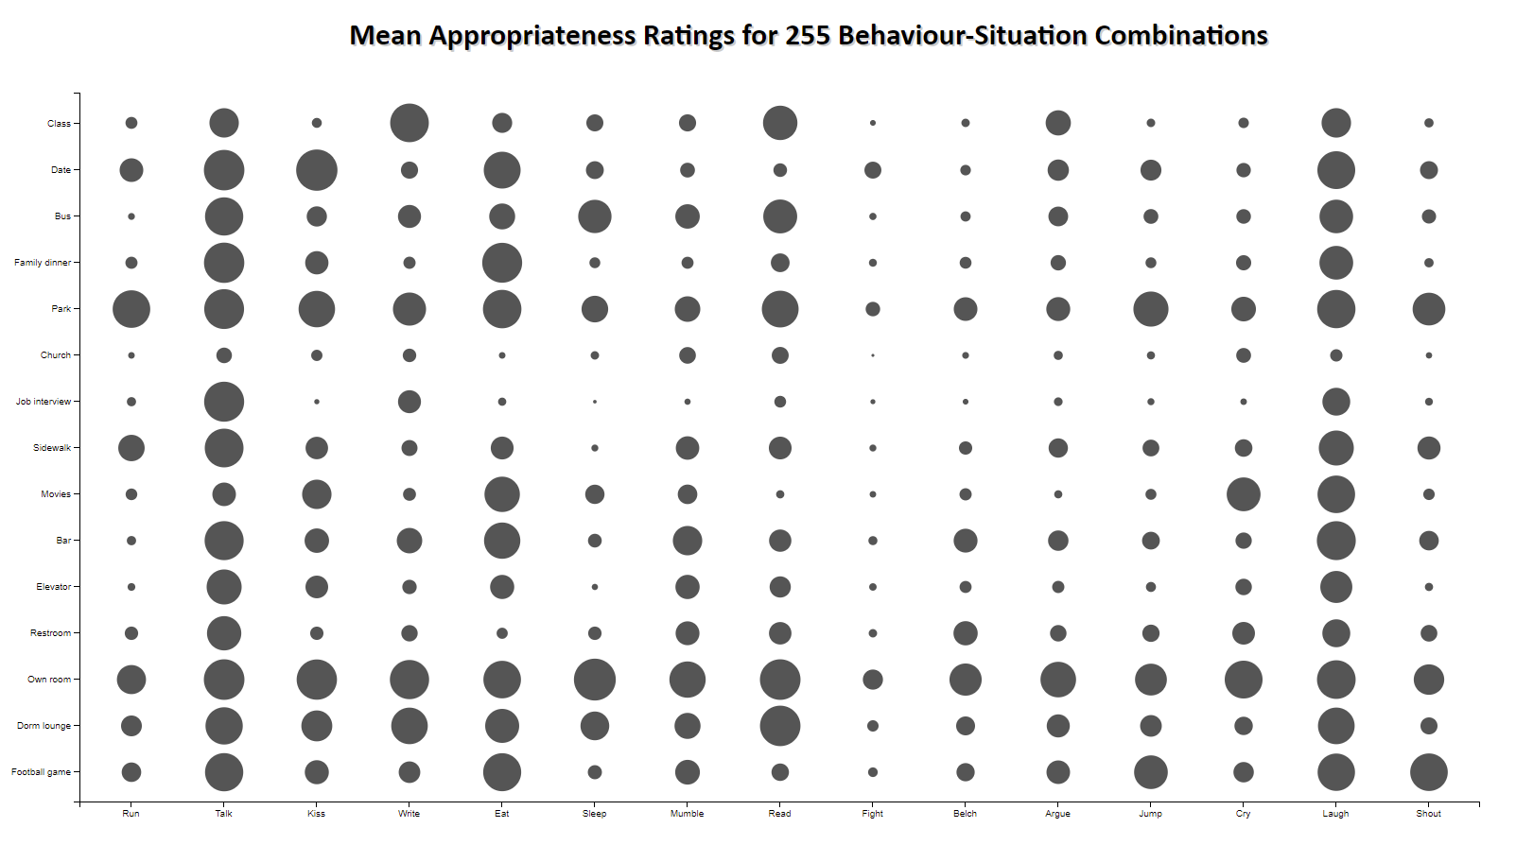
Interaction
When visualizing the data, I wanted to make sure that the visualization was not cluttered and that there was the least amount of chart junk. Adding interactivity to this visualization helped to allow certain information that is only visible when the user wants to see it. This helps to not overwhelm the user with data they might find unnecessary. In order to allow for the hidden information to be visible, I decided to use hovering with the cursor. When the user hovers over one of the circles, the circle is highlighted to show that it is the one that the data will be pertaining to and the mean for that circle also becomes visible. The radius of the circles is already representative of the mean, but I wanted to make sure the actual data number was there for the user to see if wanted. 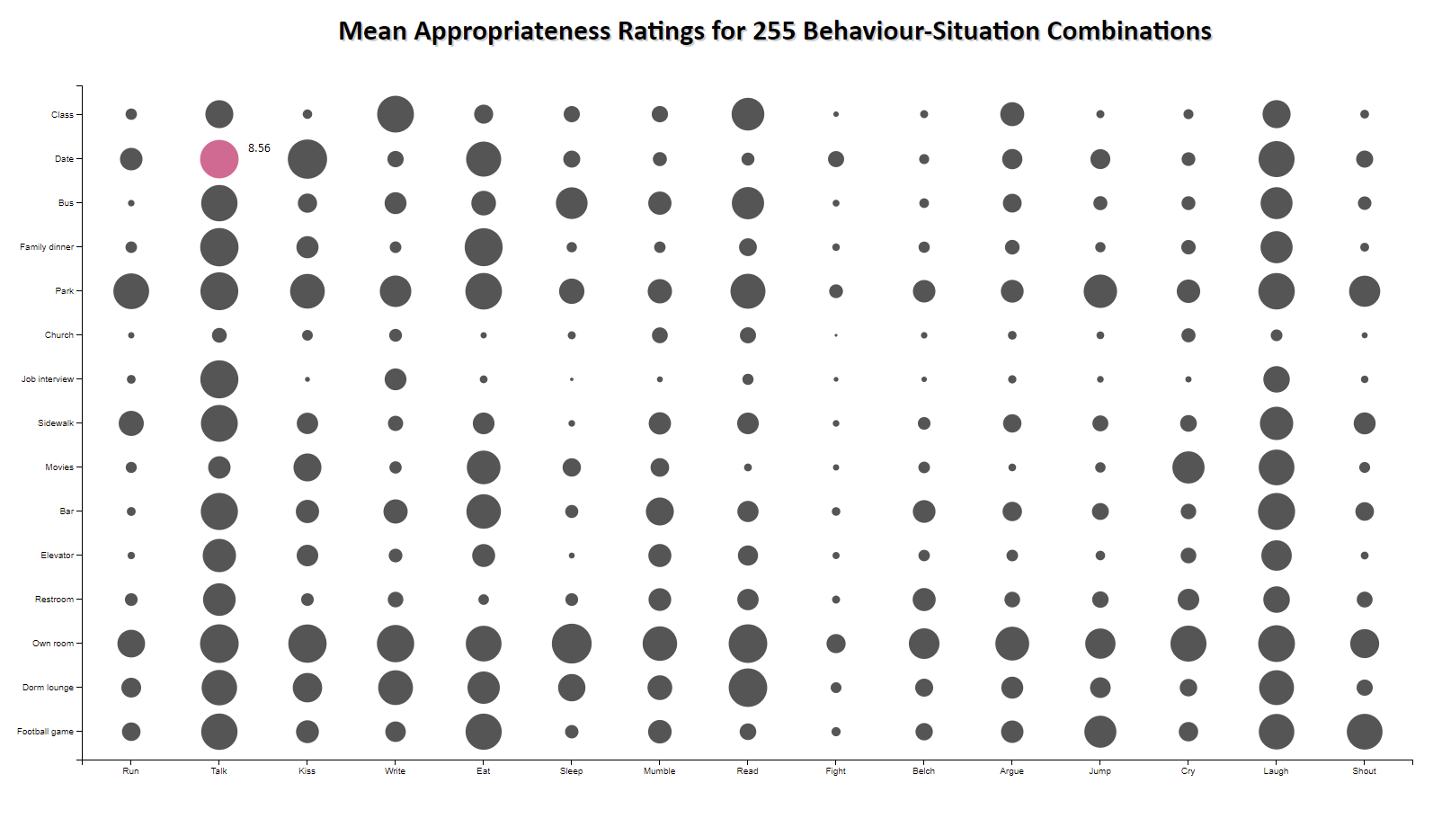
I also wanted the average to be part of the interactivity. When a user hovers over the behaviors on the x axis, the average of the whole column will be displayed underneath along with the whole column being highlighted. This helps to show which data set is being explained. 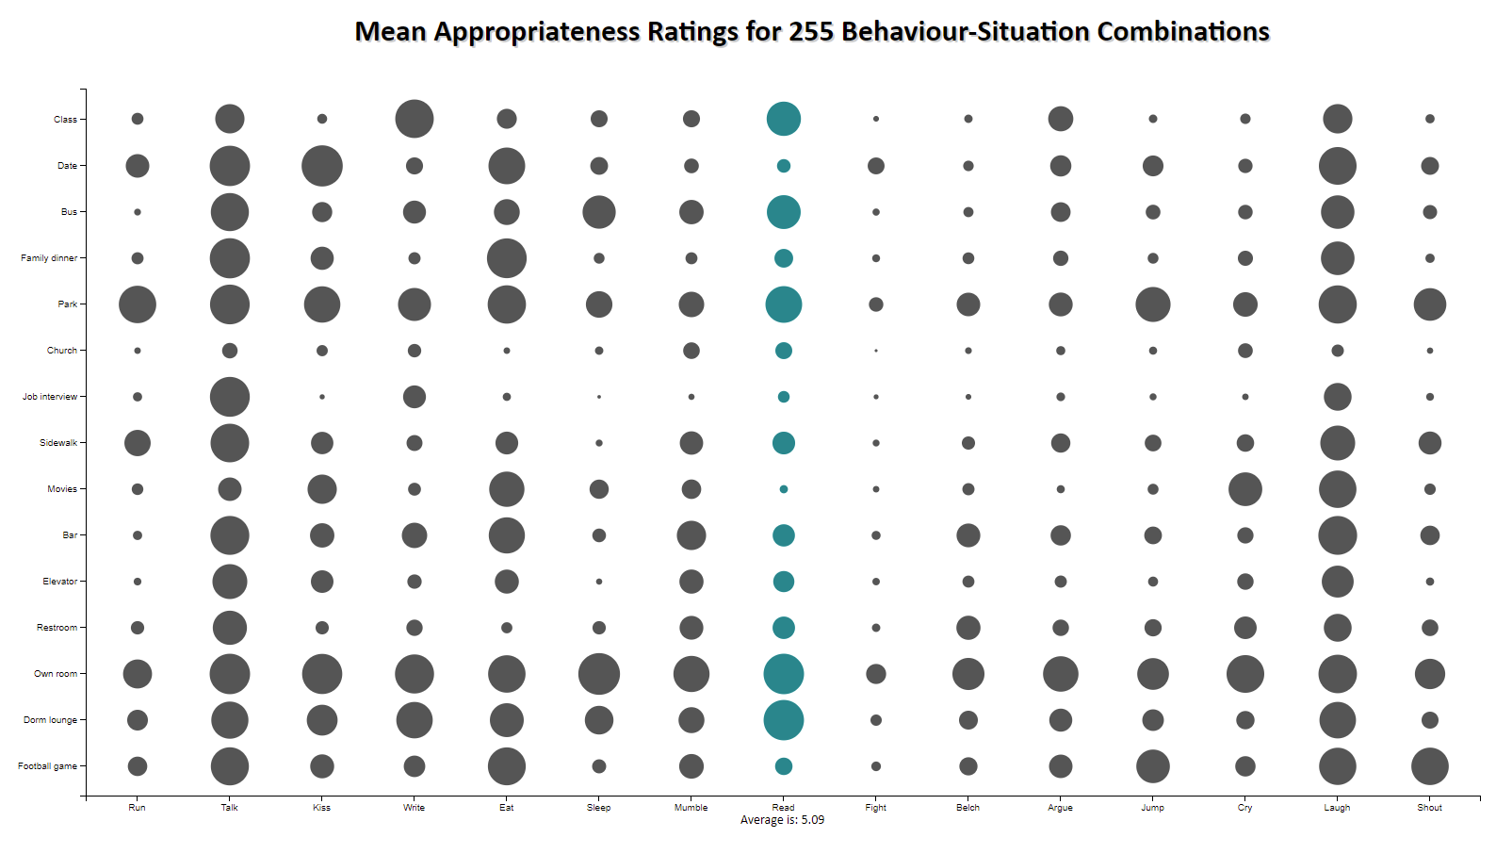

Positive Features

There are many positive features to the visualization of this data set. By taking a glance at the visualization, it is easy for a user to see which behaviours are appropriate in most situations, which ones are very inappropriate in most situations and which behaviours are appropriate or inappropriate depending on the situation you are in. Another positive feature is the interactivity of the visualization. Without the interactivity, key information would not be available by just using circles. With this interactivity, a user is able to get definite numbers for a single case, or averages for the whole behavior for all situations. They can print the chart, with a highlighted circle or highlighted column with the exact number. They can also just print the chart with just the circles which does a fantastic job of representing the data visually without the need of numbers.

Source for the data in the table above:
Price, R.H. and Bouffard, D.L.
Behavioral Appropriateness and Situational Constraint as Dimensions of Social Behavior
Journal of Personality and Social Psychology
1974, Vol. 30, No.4, 579-586

