CPSC 583 – Assignment #2 – Report
Description of Data
The data I used for this assignment was the UK Food Trends that we were provided with in class. It provides insight into the types of foods that are eaten in the UK and how much of these items were consumed each year, for 30 years from 1974 to 2014. It is useful to visualize this data because the data set is large and it is very difficult to see any trends or key features in the data, just by looking at the table. By visualizing the data, it is possible to see both good and bad trends in certain food groups, which can impact the health of individuals.

Directions and Change
I produced 10 distinct sketches in order to determine how I could visualize this data. Since the data set was very large and the data summary was just a fraction of the data set, it was hard to come up with different ways to represent the data. Going through my sketches, a lot of the ideas seemed to work very well for the data summary, but when I thought about applying them to the data set, it seemed that the ideas would be hard to expand to include all of the data without making it very cluttered. Therefore, I thought the sketches relating to trees seemed to stand out the most because of the way the data set was created. Since each section has a parent with multiple children, I decided a tree would be best. I found it a challenge to determine how best to incorporate the years and all of the data for them. I thought that a timeline would be a good way to present the data, in an easy to view way.

Representation
The mapping from the data to the visual representation was in the form of each node having a colour to distinguish the different years. This makes it easier to understand that the nodes contain different information.
Each node in the tree (pictured below) is sized according to 4 groups to make comparing them easier. The first group was all of the nodes in which the amount section was blank, indicating that no statistics for that food group were collected. I gave each of these nodes a radius of 1. The second group was all of the nodes in which the amount section was less than 100. I gave each of these nodes a radius of 5. The third group was all of the nodes in which the amount section was greater than 100 but less than 1000. I gave each of these nodes a radius of 10. The fourth group was all of the nodes in which the amount section was greater than 1000. I gave each of these nodes a size of 15. By using different node sizes, it is much easier to compare the food groups in order to see which ones are consumed more than others.
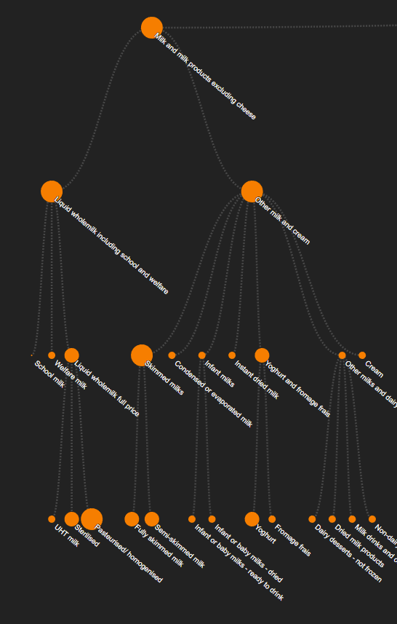
I also represented each parent and their children using colour. Each parent in the tree has a specific colour and all children of that parent have the same colour as their parent. This helps to make the certain groups pop out and make the tree more readable.
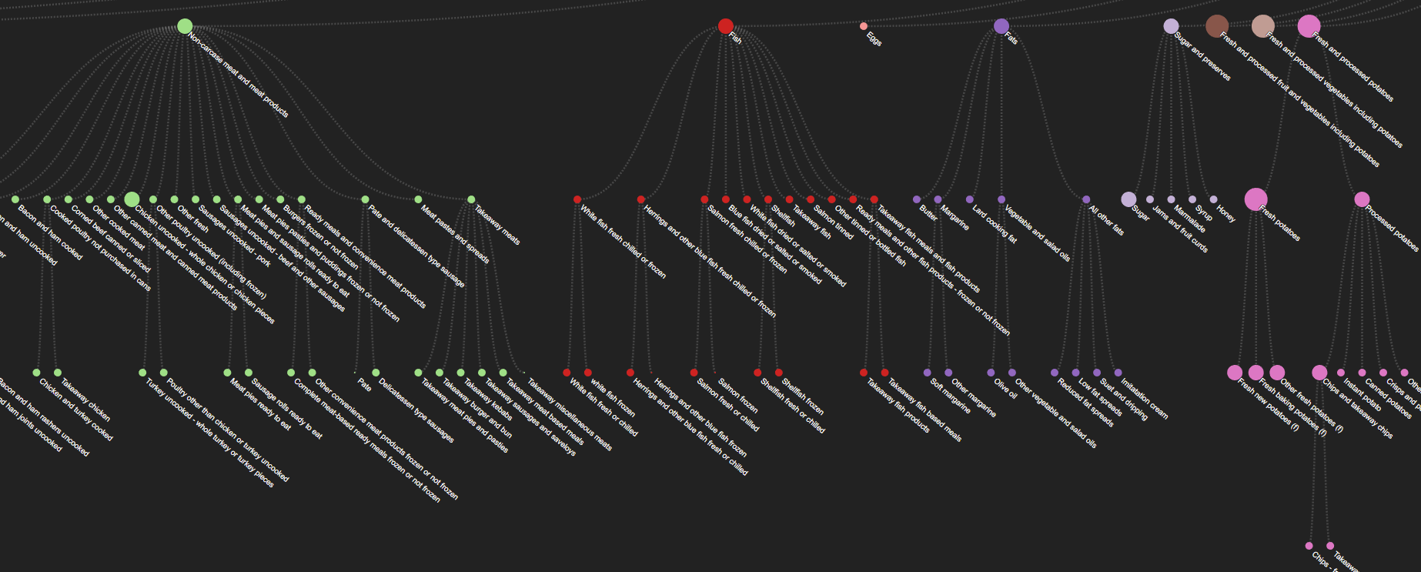

Presentation
I created a line graph of nodes in order to show the difference of the amount of food consumed during each year. The y position is the total amount of food for that year. The years are placed in a timeline with the first year on the left and the last year on the right. This allows the user to see the trends in total food consumption from year to year.
I decided that creating a tree for each year was the best way to present the data fully. It makes it easy to see the relationships between the foods in each group and is easy to read and follow. Although the tree graph is large, it contains all of the information in the data set except for the category column.
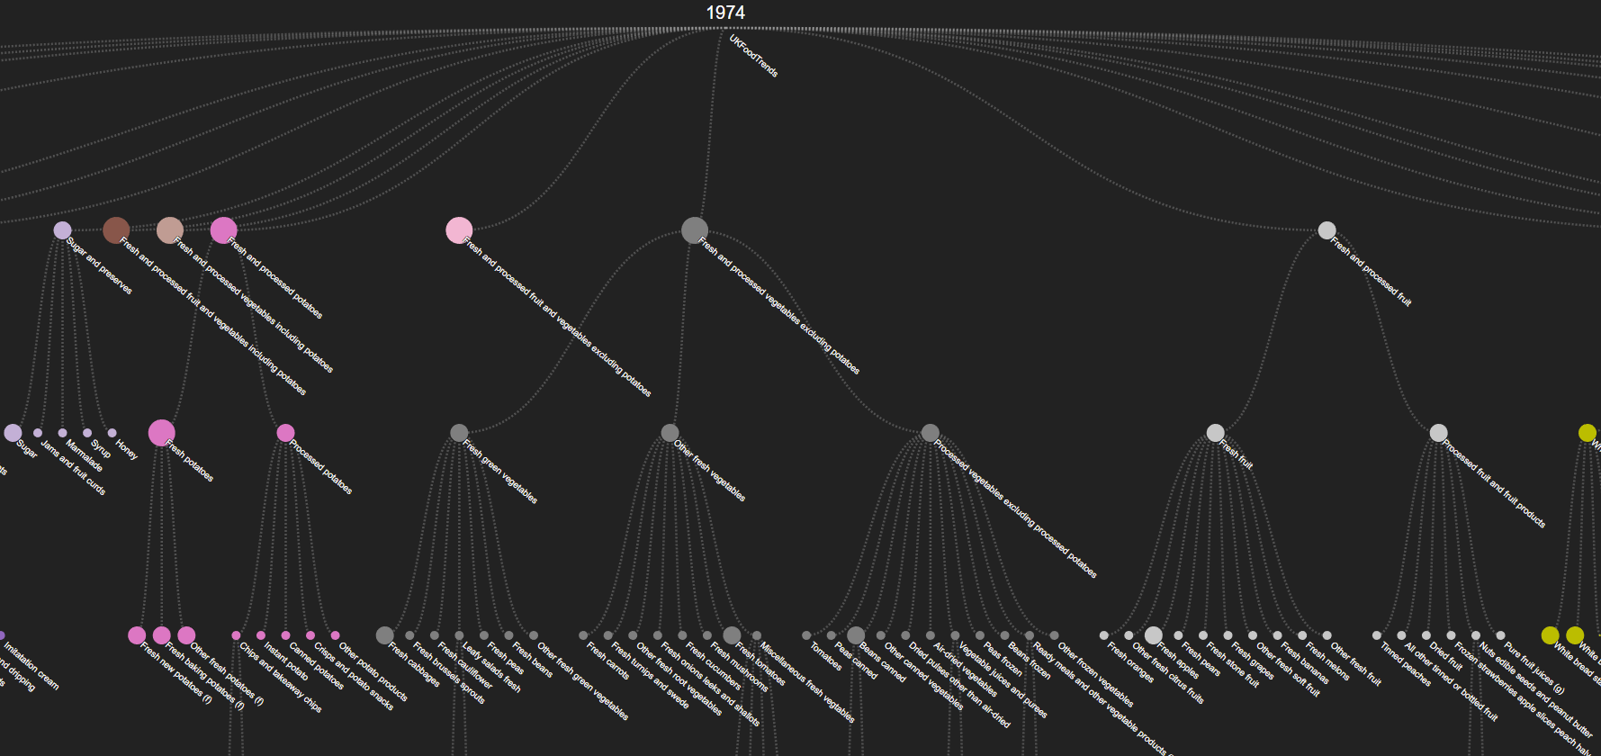

Interaction
For user interaction, I decided to use hovering over the nodes in the timeline in order to hide data that the user only needs to see, when choosing an option to click on. When the user hovers over a node in the timeline, the year for that node appears.
Clicking on any of the nodes in the timeline brings you to the full tree for that specific year.
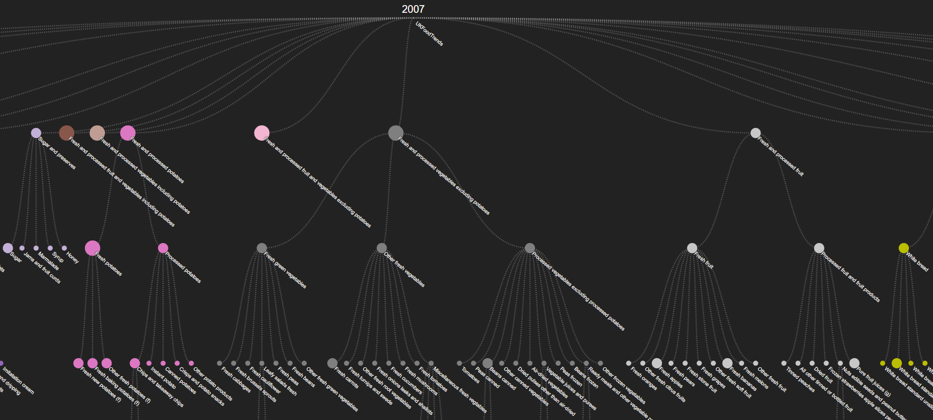
I included a Back to Timeline button, that when clicked, brings the user back to the timeline in order to choose another year.
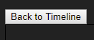
Hovering on any of the nodes in the tree for the year chosen will give the amount consumed for that type of food and for that year.
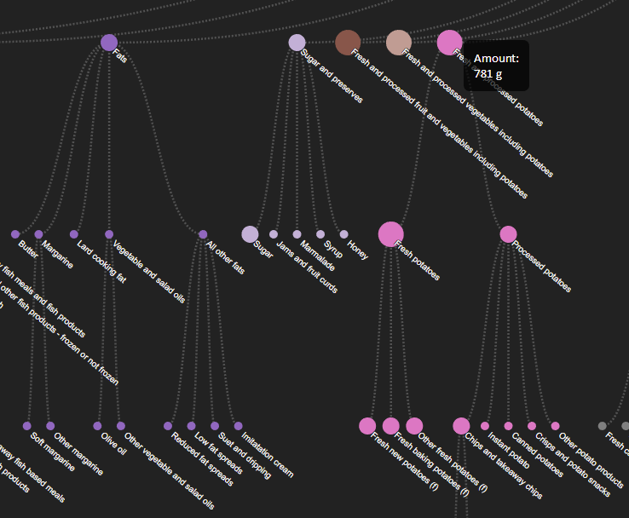

Positive Features
There are many positive features to the visualization of this data set. By taking a glance at the timeline it is easy to see that there are trends that can be seen between each of the years. For example, from 1991 to 1992 there is a large jump in food consumption. When looking at the data in the trees for these years, I can see the reason for this is because they started to collect data on soft drink consumption. As well, the trees for each year make it easy for the user to explore the data for each year and make comparisons between the different food groups. The interactivity of the visualization is helpful in order to guide the user through the large amount of data that the data set contained and be able to see the trends in foods consumed. The interactivity also provides a way to hide data that the user might not be interested in, but makes it available if needed. It also helps to keep less information on the screen, so the user doesn’t have to scroll unnecessarily.

